OOAD LAB EXPRIMENT

UML FOR LIBRARY MANAGEMENT SYSTEM

USE CASE DAIGRAM

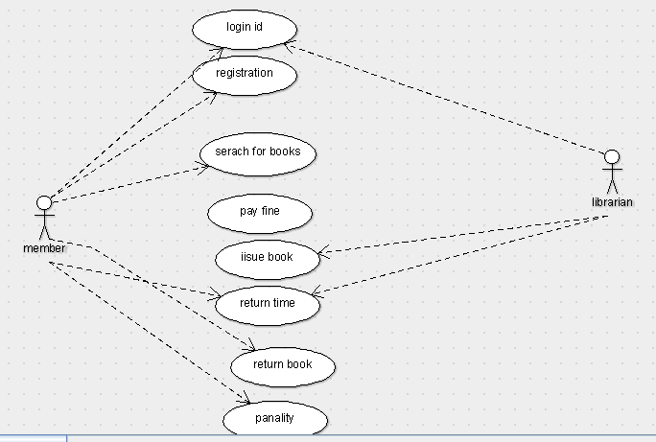

CLASS DAIGRAM

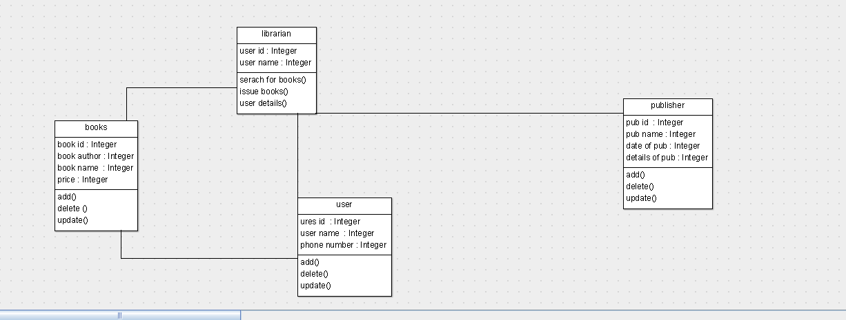

ACTIVITY DIAGRAM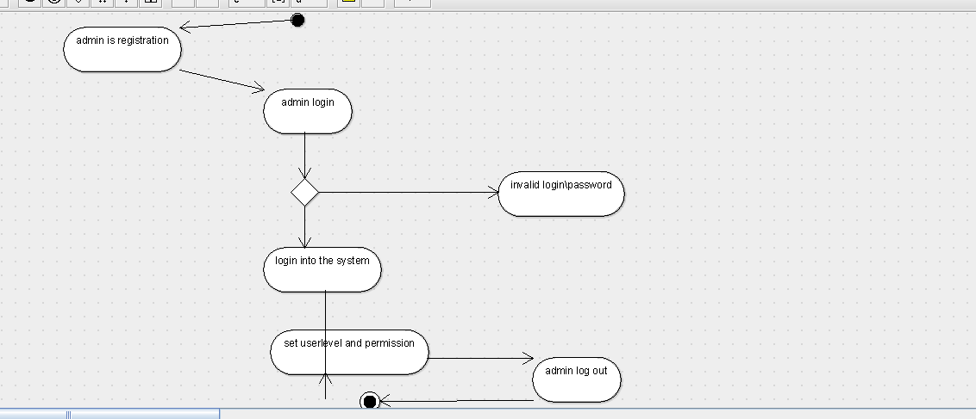

SEQUENCE DAIGRAM

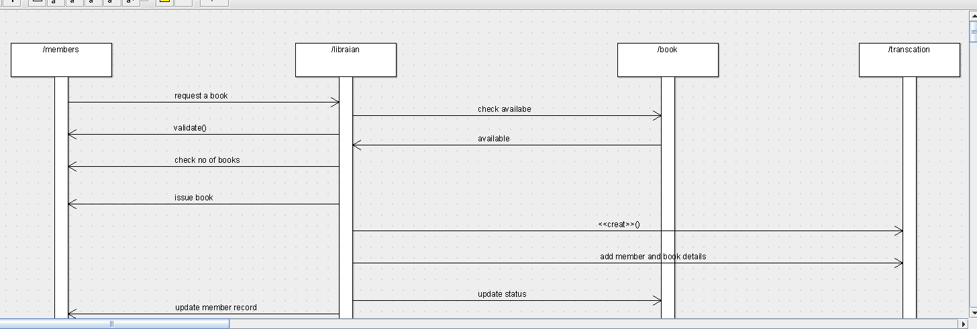

COLLABRATION DIAGRAM

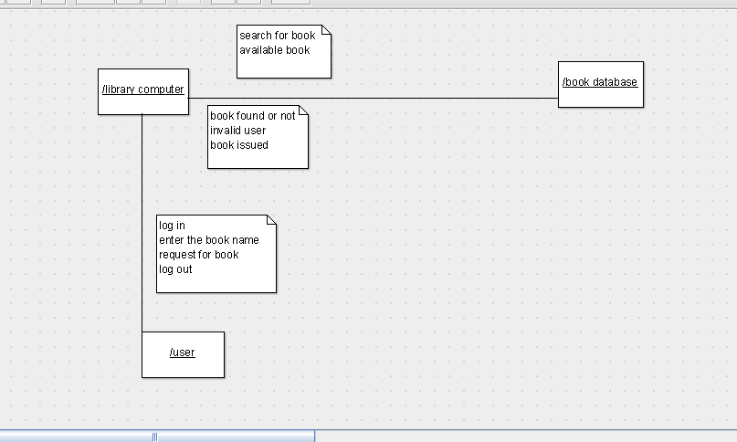

STATE CHART DAIGRAM

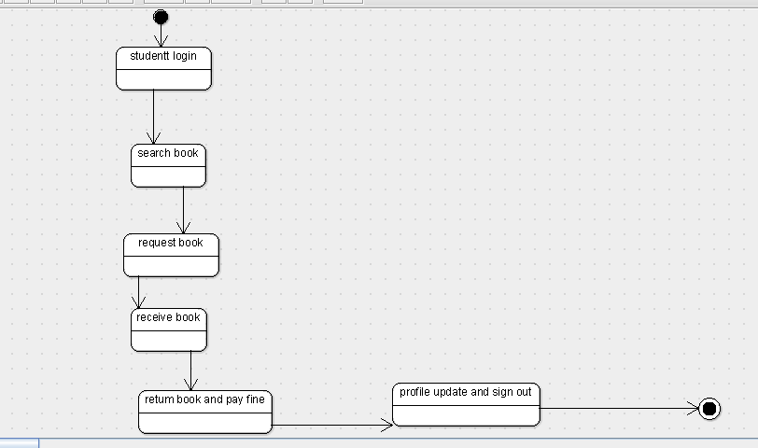

COMPONENT DIAGRAM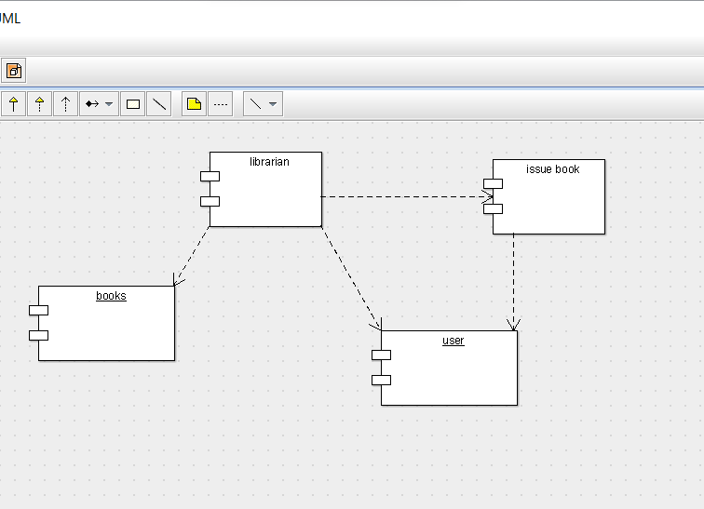

DEPLOYMENT DIAGRAM

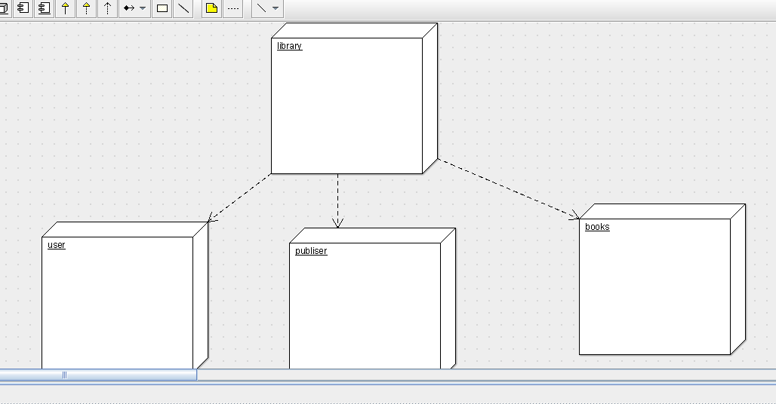

PACKAGE DIAGRAM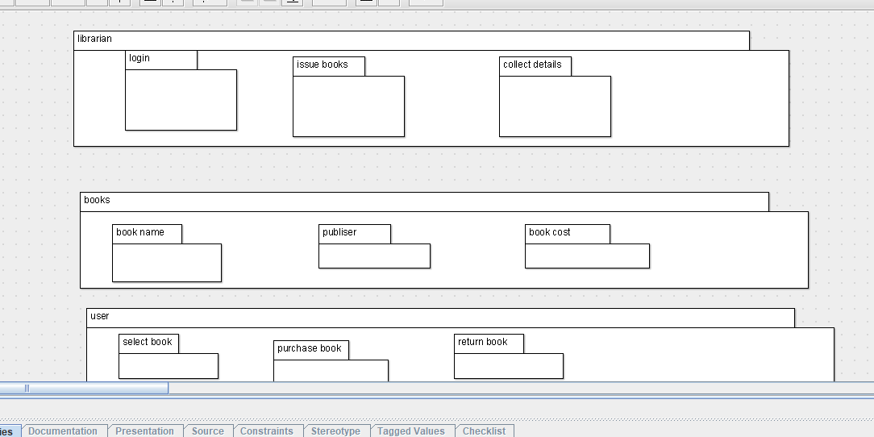

Program code

package member;

import Integer;

import java.util.Vector;

public class books {

  public Integer book id;

  public Integer book author;

  public Integer book name ;

  public Integer price;

    public Vector  myuser;

    public Vector  mylibrarian;

  public void add() {

  }

  public void delete () {

  }

  public void update() {

  }

}

Member

package member;

import Integer;

import java.util.Vector;

public class librarian {

  private Integer  user id;

  private Integer user name;

    public Vector  myuser;

    public Vector  mypublisher;

    public Vector  mybooks;

  public void serach for books() {

  }

  public void issue books() {

  }

  public void user details() {

  }

}

Publisher

package member;

import Integer;

import java.util.Vector;

public class publisher {

  public Integer pub id ;

  public Integer pub name;

  public Integer date of pub;

  public Integer details of pub;

    public Vector  mylibrarian;

  public void add() {

  }

  public void delete() {

  }

  public void update() {

  }

}

User

package member;

import Integer;

import java.util.Vector;

public class user {

  public Integer ures id ;

  public Integer user name ;

  public Integer phone number;

    public Vector  mylibrarian;

    public Vector  mybooks;

  public void add() {

  }

  public void delete() {

  }

  public void update() {

  }

}